Flood Protection
Strategy and Assets
Manager : Brendan Paul

Report for Period Ending 5 November 1999

1. Waikanae River Floodplain Management [Graeme Campbell]

Work on the Waikanae River focused on the State Highway 1 to Maple Lane project. The design is complete, Resource Consents obtained and tenders let to supply rock rip-rap. Construction work is now out to tender and work due to start on 1 December 1999. This work is reported on in more detail in Report 99.650 in this order paper.

The annual ‘Friends of the Waikanae River’ walkover was on 19 October 1999. Approximately 30 people attended the walkover, starting at the Water Treatment Plant and ending at Pukekawa Reserve. A meeting followed at the local marae where the group selected a sub-committee to consider and finalise the Terms of Reference; to be presented to their next meeting on 29 November 1999. The Terms of Reference may be wider than those originally drafted. Provided the ‘Friends’ continue to provide the input and advice required by the Flood Protection Group, a wider role will increase the group’s value to the Waikanae River environment. Support from other Council divisions may be needed in specialist areas, e.g. Care Groups, Community Connections, Environmental Education, etc.

The Ecological Strategy, developed in consultation with local iwi, is complete. The key content of the strategy was presented to the ‘Friends of the Waikanae River’ group on their annual walkover of the river held on 19 October 1999. The document should provide a good focus for ecological restoration and enhancement work undertaken by interested groups or organisations as well as Flood Protection.

2. Otaki River Floodplain Management [Graeme Campbell]

- Otaki Floodplain Management Plan [Graeme Campbell]

Report 99.650 in this order paper covers progress on the flood damage repairs and capital improvements. The Rahui and Chrystalls projects are reported separately, below.

An ‘Otaki Friends of the River’ meeting, held on 18 October 1999, considered the Fish & Game Council’s proposal for game bird shooting on the Otaki River at Chrystalls, the South Bank, and at the Estuary. The group was unable to support or object to the proposal until further considering its own goals for environmental and other opportunities on the river. This will not be complete until the beginning of December 1999 and so precludes a report to this Landcare Committee meeting as programmed. A report will now be presented to the February 2000 Landcare Committee meeting. The Fish & Game Council have been advised of this delay.

The general response from the wider Otaki community, sought as part of the consultation process, does not favour shooting on the Otaki River. The ‘Friends’ initial view is that shooting conflicts with their objective to increase the recreational use of the river environment. Legal advice will clarify the Council’s powers to restrict shooting. Where land has been vested, the Council has the same powers as an owner and can therefore control land use. If land is designated as soil conservation reserve then the Department of Conservation, on behalf of the Crown, may have the final say. A general opinion on delegated responsibility through soil conservation reserves has been requested, plus clarification of the status of the land in question.

(2) Upper Rahui Improvements [Paula Williams]

Documentation for a management easement in favour of the Wellington Regional Council, covering the stopbank and retreat areas, is now complete. Plans and documents will be signed by all parties and lodged with LINZ. The bank protection works are substantially complete with only minor tidy up work remaining. All works undertaken as part of the Upper Rahui Project are essentially complete. Gravel extraction from the retreat areas is on schedule, through to the end of June 2000.

Some of the tidy-up works include removing a silt bund adjacent to the new berms. The material will be used for the Chrystalls stopbanking project and extracted by the stopbank contractor. This will be done in February 2000.

(3) Chrystalls Bend Stopbank [Paula Williams]

AC Consulting Group Ltd has been re-engaged for construction management. The works are currently out to tender, closing on 16 November 1999. A separate report, PE99.648 in this order paper, elaborates on the project.

3. Hutt River Floodplain Management (HRFMP) [Daya Atapattu]

The Advisory Committee recommendation for a modified “Risk Based” 2300 cumec design standard, referred by the Landcare Committee to Policy and Finance for consideration through the Long-term Financial Strategy (LTFS), was referred back to the Landcare Committee for further consideration. This is further reported (99.679) in this order paper.

At its 12 October meeting, the Landcare Committee requested further investigations on “local area” modifications. These are proceeding and will be reported to the Hutt River Floodplain Management Advisory Committee (HRFMAC) on 6 December 1999.

Works programmes for the principle Western Rivers funding options, $2 and $4 million per year, are well underway – an appropriate “mix” of works can then be available for integration into LTFS at the appropriate time.

A detailed programme to develop non-structural measures for the Hutt River floodplain is now complete. The “non-structural” measures for the river corridor, floodplain and upper catchment will be developed from October 1999 to February 2000. Existing emergency procedures will also be reviewed during this period. The options will be reported to the HRFMAC at its December 1999 and February 2000 meetings, before proceeding with public consultation during the period March to May 2000. Non-structural investigations will be completed by the end of June 2000.

Delineated river corridor hazard zones are now complete. A working group of Regional Council, Hutt City and Upper Hutt City officers have reviewed the hazard zone maps. Land use criteria appropriate for the hazard zones is progressing. These investigations will be reported to the HRFMAC on 6 December 1999.

A review of overseas approaches and practices for non-structural measures, and in other parts of New Zealand, is complete. These will be reported to the HRFMAC on 6 December 1999.

The Environmental Strategy investigations for the Hutt River are to programme. Consultation on objectives and options runs to mid December 1999. The newsletter, which forms the basis for consultation, is complete. Newspaper inserts appeared in the Hutt News and Upper Hutt Leader on 9 and 10 November 1999 respectively. The newsletter goes to targeted interest and user groups in early November 1999, and requests their views on the proposed options. Information posters, for various locations on the river, will be in position by mid November 1999. An update on the environmental strategy consultation will be given to the HRFMAC on 6 December 1999.

4. Asset Management Plans [Malcolm Abernethy]

The generic base plan component of the “Western Rivers Asset Management Plan” is currently being reviewed prior to submitting for Audit NZ approval.

The Data Management System specifications are complete and work is progressing well developing the system.

For each of the Hutt, Otaki, Waikanae and Wainuiomata Rivers and the Porirua Stream, data is being compiled for the river specific components of the Asset Management Plan.

The river specific plans also include Asset Maintenance Plans which support the Zero Based Maintenance estimates. An Asset Maintenance Plan prescribes the routine, periodic or cyclic maintenance that will be carried out to ensure assets are maintained in perpetuity.

Work has also commenced on review of the Asset Valuation Methodology to value and re-value assets in each of the river specific plans.

5. Wainuiomata Flood Hazard Assessment [Phillip Purves/Paul Ollett]

A draft report on the Wainuiomata Flood Hazard Assessment hydraulic modelling was completed in mid October. The results provide design flood level information along the full length of the river, and include flood-spread maps. Flood damages have also been assessed for the floodplain urban area. The report is currently under review before inclusion in the summary Flood Hazard Assessment report.

Scoping for the channel management and river morphology component (plan form of the river and gravel behaviour) of the flood hazard study is now underway.

6. Planning and Development Services [Phillip Purves]

Written requests for information or advice attended to during September and October 1999:
Sept/Oct YTD

Requests brought forward 18 14
Additional requests received 46 80
Responses provided 45 75
Outstanding requests 19 19

The Flood Protection Group provided input to the last of the Hutt City Council Proposed District Plan hearings on issues affecting the Group. The first hearing for the Upper Hutt City Council Proposed District Plan, 31 August 1999, concerned the St Patrick’s College Estate land at Silverstream. Development of this site is locally contentious (the proposed Promall Development) and flooding issues are closely scrutinised by many submitters.

Determining flood level information for the Wainuiomata floodplain (as part of the Wainuiomata Flood Hazard Assessment project), with closer subdivision provisions for rural areas (as part of the Proposed Hutt City District Plan), has raised local interest in development of that floodplain. Already, two substantial subdivision proposals have been referred to us for flood level information. The latter relates to house sites proposed for the floodable margins of the floodplain. This is consistent with the greater public awareness that accompanied the Kapiti floodplain management plans.

7. Manager’s Comment

Work programmes at this time of year gather momentum, particularly construction projects (to fit the construction season). Investigation and planning projects must also make good headway, as the last three months of the year are generally needed to collate, and tidy up reporting aspects.

On our staffing side I received and approved a request for one year’s parental leave from one of our Assistant Engineers, Paula Williams. It is likely, however, that Paula will return to Australia over that period. Paula has worked with us since May 1997. Mark Healey, another Assistant Engineer in our group, has resigned to take up a position in Greymouth with Opus Consultants. Mark handled the channel management component of the HRFMP Design Standard and is currently working hard to bring that work together. Mark started with us in August 1996. We will miss them both, but wish them well in their new directions – and a new round of recruitment needs to begin, to maintain our progress.

BRENDAN PAUL
Manager, Flood Protection (Strategy and Assets)

Flood Protection
Operations
Manager : Geoff Dick

Report for Period Ending 5 November 1999

Flood Protection Operations and Maintenance [Geoff Dick]

1. Hutt River

Construction of the Manor Park Golf Course flood repairs is progressing very well. Debris fences are in place and willow planting is complete. The willows are growing well in the warm spring weather. Delivery of rock for the groynes and rock heads is now underway. It is planned to start construction of these in early November.

A large signboard informing the general public about the Manor Park Golf Club work will shortly be installed on the eastern Hutt Road opposite the site.

Construction of the proposed rock-line at Memorial Park on the River Road is complete. Approximately 1500 tonne of rock was used to repair a section of debris fences and willows destroyed in the October 1998 flood. The job included realigning a short section of the existing upstream rock-lining.

The annual cross-blading programme in the Hutt River is underway. Work has been completed at Avalon and Melling to correct meander patterns and protect new willow plantings. The front edges of stable beaches have also been loosened, by ripping them with the bulldozer, to encourage the movement of gravel through the system, and relieve the pressure on adjacent bank edges.

Routine maintenance work in the Hutt River in the period included completion of the spring fence line clearance run, berm repairs at Nash Street, and installation of vehicle control bollards at Boulcott.

2. Hutt River Mouth

All six buoys marking the off-shore deposition area are now in place. Winstone Aggregates Ltd will shortly commence dumping the surplus stone and shells within the approved site.

I attended a meeting at the Waiwhetu Marae to discuss the dumping of surplus materials at the Hutt River mouth. The meeting was called by Iwi to discuss an article written by Jim Mikoz from the Wellington Recreational Marine Fishers Association. Mr Mikoz is concerned that the dumping may have negative impacts on an adjacent aquifer vent. The meeting went well and I believe the Te Ati Awa representatives now have a much clearer understanding of the issues.

3. Kapiti Rivers

Construction of the Upper Rahui edge protection works is largely complete. The installation of debris fences and willow planting is complete over the full length of the project. The final section of trench planting at the upstream end of the project is on hold until the underlying river silt is required for the Chrystalls Bend project. The Upper Rahui gravel extraction is proceeding well. To the end of October, Winstone Aggregates had extracted 42,400 cubic metres of the proposed 120,000 cubic metres.

Construction of the new 100m section of rock lining at lower Chrystalls is complete, including reconstruction of the berm and soiling and sowing it to grass.

The Otaki River edge protection and channel maintenance programme is now underway. Three further debris fences are being constructed at Hughes to continue the project to re-establish the willow buffer zone at this location. Staff also inspected the north bank bluffs at Empsons in preparation for some significant channel shaping work aimed at halting the ongoing erosion at this point in the river. It is proposed to commence this work at the end of November 1999.

Mowing of the Otaki River stopbanks and berms is in full swing with the spring growth underway.

4. Watercourses

The annual Pinehaven Stream maintenance run was completed in the period. Numerous trees have been removed from several watercourses, in particular from the Waiwhetu Stream and Wainuiomata River, probably as a result of the recent windy weather.

The Waitohu Stream mouth is being monitored closely at present. The mouth has migrated a long way south and is eroding the foredune. A further mouth cut may be required.

5. Firth’s Building Demolition, Melling

Demolition of the former Firth’s building on the Melling berm is now complete. The contractors, Jurgen Bros. Ltd, completed the work in two weeks. The next stage of the project is to shape the site, then topsoil and sow to grass to develop the area as mown river berm. Some minor landscaping is also proposed including development of a small car park at the Block Road entrance, and some native planting next autumn.

Regretfully the planned rescue dog exercise did not eventuate because of the early start by the contractor and unavailability of the rescue dog personnel.

6. Work for Others

Mabey Road staff are being kept busy with a significant number of jobs for Resource Investigations. Work completed includes fabrication and installation of a new recorder tower in the Orongorongo River, installation of new recorder intake pipes at Manuka Track and Leonard Wood Park, Wainuiomata River and at Estuary Bridge on the Hutt River. Staff also fabricated a new recorder tower for the proposed new Waikanae River recorder station.

The other major job completed was sealing seven large bores from the former Randwick pumping station at Hutt Park. This project proved a significant challenge and tested the ingenuity of staff. The first attempt to install a stand pipe (necessary for placement of the cement grout) led to an uncontrolled discharge from the bore field. The crew worked all night to recap this bore, but not before a large pond had formed in the Hutt Park Golf Course. It turned out that at least one large valve isolating the various bores proved to be open rather than closed. The resulting temporary pond was named “Lake Angus” in honour of the individual responsible. The bore field is, however, now fully sealed, bore heads removed and the site landscaped and grassed.

7. Gravel Extraction

Gravel extraction figures for the year to 31 October 1999 are set out below.

 |  |  | Period Year  1999/2000  (cubic metres) |  | Year  1998/1999  (cubic metres)
River | Area | Contractor | Period | Year | Full Year
Hutt | Estuary | Winstones | 5,096 | 13,916 | 42,630
Hutt | River | Winstones | Nil | Nil | 2,967
Otaki | River | Winstones | 992 | 2,112 | 15,854
Otaki | Upper Rahui | Winstones | 10,650 | 21,970 | 20,454
Waikanae | River | Winstones | Nil | Nil | Nil
 |  | TOTALS | 16,738 | 37,998 | 81,905

8. Manager’s Comment

Three staff attended this years Riverworks Supervisors Seminar hosted by the Tasman District Council. Field trips were made to sites near Nelson, in the Motueka Valley and in Golden Bay. The seminar is an annual event and serves as a useful forum for the sharing of ideas and solutions for the every day practical problems encountered in our work. A small report is being prepared to record the seminar highlights and photographs taken.

GEOFF DICK
Manager, Flood Protection (Operations)

Regional Parks (Strategy & Marketing)
Manager : Susan Edwards
Report for Period Ending 5 November 1999

1. Manager’s Comments (Susan Edwards)

Recreation Association Conference and Auckland Regional Council (ARC) Visit

Anne Manley attended the New Zealand Recreation Association Conference in Auckland from 7 - 9 November. She found the Conference interesting and useful. After the Conference she visited the Auckland Regional Council Parks staff to discuss a number of mutual issues; concessions, park charges, asset management planning and marketing. As ARC is the only other regional council with regional parks, we find it extremely useful discussing issues we have in common and sharing information.

Kilmister Block, Belmont Regional Park

I was asked by Hutt City Council staff to comment on a proposal to their Council on the sale of part of the Kilmister Block of Belmont Regional Park. The proposal included:

- the sale of the Kilmister Block below the 250m contour;
- the retention of the land above the 250m contour (including the geological features, bush remnants, Speedy’s Stream bush, and walkways) in the Park;
- this Council being appointed to control and manage the land, with a view to it being vested in the Regional Council at a later date.

They sought my view on whether this Council would support the proposal. I responded that this Council would probably prefer the whole of the Kilmister Block to be retained in the Park, but that the proposal is likely to be viewed as a good compromise as it retained the core values of the Block in the Park. I suggested that the Council is likely to prefer that the land be vested in it rather than being appointed to control and manage the land, as such an appointment could be revoked at any time. I also asked that before they make any final decision they formally seek the view of the Committee, as the time allowed for a response did not enable me to report the matter to you. I hope to be in a position to advise you of their position at the meeting.

Long-term Financial Strategy

A significant amount of work has gone into providing accurate costings for the Long-term Financial Strategy and projects requested by Councillors and the public (through Annual Plan Submissions) for inclusion in the Strategy.

Presentation to the Wellington Conservation Board on East Harbour Regional Park

I was asked by Councillor Laidlaw to do a presentation to the Wellington Conservation Board on the East Harbour Regional Park Strategy. Bruce Andrell and I attended the meeting and presented the Strategy as approved by the Landcare Committee in July. We believe the presentation went well and that the Board seemed comfortable with our work to date.

The Board did stress the need for consultation on the Strategy, particularly as it differs from the Park Management Plan. There was a strong emphasis on the need to discuss the proposals with tangata whenua, particularly the work we are doing on identifying the heritage assets for asset management purposes and the Signature values.

Holiday in North Queensland

During October I spent nine enjoyable days on holiday in North Queensland; based in Port Douglas and Cairns. Apart from being a greatly needed break, it was interesting from a work point of view as I went to two National Parks and a State Forest. Some things I saw could be applied to our Regional Parks and Forest. There were an interesting range of concession activities operating in their Parks and Forests.

2. Resource Management and Planning Issues (Anne Manley, Graham Laws & Ross Jackson)

State Highway Upgrades

State Highway 1 - MacKays Crossing

Regional Parks staff have continued working with Transit New Zealand and consultants on the State Highway 1 upgrade affecting Queen Elizabeth Park.

Several options have been identified and officers and Transit New Zealand staff favour the construction of a railway overbridge at MacKays Crossing. This would provide a satisfactory entrance into Queen Elizabeth Park and will have less impacts on the park than other options they have examined. The road would remain on the Eastern side of the railway line. Transit are currently seeking public comment on the proposals.

State Highway 58 - Haywards Hill

There have been conflicting views within the Council on Transit New Zealand’s State Highway 58 upgrade proposal. Regional Parks have supported the proposal as we hope the upgrade will reduce the likelihood of a road being put through Belmont Regional Park from Hill Road (through the Kilmister Block) to Cannons Creek. Belmont is likely to be significantly affected by the Transmission Gully project. To also dissect the Park through the Kilmister Block would impact on recreational users (as the Park would be split into three separate areas) and pose management difficulties. We believe the State Highway 58 upgrade impact on the Dry Creek portion of the Park will be significantly less than the Kilmister Block road.

Asset Management Planning

Asset Management Planning is progressing. Work has been undertaken on:

- finalising development of the asset database;
- mapping all assets on GIS;
- refining costings for inclusion in the Long-term Financial Strategy process.

We hope to hear back from Audit New Zealand soon on their view of the Draft Asset Management Plan we presented to the Landcare Committee at the last meeting.

Concession Applications

We have approved a concession application to take motorised recreation tours through the Akatarawa Forest and undertake other corporate team building activities at the Maungakotukutuku Valley entrance to the Forest. The concessionaire hopes to begin operating early in November.

Queen Elizabeth Park Whareroa Beach Toilets

The new toilets at Whareroa Beach in Queen Elizabeth Park were opened during October. Public comments have been very favourable so far.

Promotion Programme and Events

During October several promotional advertisements have been put in newspapers and publications in the Wellington Region to attract visitors and school groups to the Regional Parks.

A display was undertaken at the Upper Hutt outdoor recreation expo in October. Regional Parks, Strategy & Marketing and Operations staff were present to answer any queries from the public and ensure they received correct information to meet their needs.

A Raumati resident, Mrs Di Dias recently organised a Sunday community planting on an unused piece of road reserve land between Poplar Avenue and Queen Elizabeth Park. Mrs Dias showed excellent initiatives in gaining approvals for the scheme and obtaining donated plants, topsoil and mulch. Ross Jackson assisted at the working bee along with approximately 50 local residents. There was a very positive response and good feeling associated with the community project.

Work has begun on the annual brochure updating and reprinting programme.

Cannons Creek, Belmont Regional Park

Regional Parks and Natural Forestry staff are intending to meet during November to examine the issues relating to Cannons Creek raised by Sylvia Jenkins in her submission on the Council’s Annual Plan. Regional Parks staff will subsequently meet with the Cannons Creek Valley Protection Association working group formed by Sylvia to discuss the matters raised in her submission and how the Council can work with the group. Some of the issues are fairly complicated as they concern areas of private land within Belmont Regional Park owned by Landcorp. Obviously Landcorp will need to be consulted and approval gained prior to implementation of the working groups plans.

The working group has asked for a site visit with Councillors to outline its concerns and what it would like to see happen in the area. There may be funding implications of what the Group wishes to do for consideration through the Long-term Financial Strategy review process.

SUSAN EDWARDS
Manager, Regional Parks (Strategy & Marketing)

Regional Parks (Operations) Department
Manager: Bruce Andrell
Report for Period Ending 5 November 1999

1. Manager’s Comments

Regional Parks Launch New Uniform

We launched the new uniform on 6 October 1999. The event was attended by various operational staff from Landcare and the Wairarapa and Chairman Stuart Macaskill. I have received positive feedback that the uniform provides a better image in the field and it meets the functional requirements of staff. I would like to acknowledge the efforts of the uniform development team, Kerrie Chudleigh, Blair Ewington and Thane Walls for their excellent work.

Eastern Mobile Ranger Starts Work

Gareth Cooper officially transferred to his new position as Eastern Mobile Ranger on 23 October 1999. Gareth is assisting the Kaitoke and Wainuiomata residential Rangers provide a rostered seven day service. Gareth will be spending the next couple of months familiarising himself with the water collection areas and his new role.

Recruitment of Queen Elizabeth Park Ranger

The recruitment of Gareth’s replacement, as Ranger Queen Elizabeth Park, is well under way. The position was advertised in Career Steps in late October and interviews were conducted in early November. I anticipate making an appointment by mid November 1999. However, it is unlikely the successful applicant will start until late December. Blair Ewington is the acting Ranger Queen Elizabeth Park until the appointment is made.

2. Battle Hill Farm Forest Park (John Bissell)

Park Reopened After Lambing

Battle Hill reopened to the public at Labour weekend following the closure for lambing. The Park has been very busy with a variety of events and all the camping areas booked out during the weekends.

Walkway Bridges Replaced

The walkway bridges have been replaced in the Bush Reserve. The new bridges meet the required safety and building standards. A number of positive comments have been received about the replacement bridges.

3. Belmont Regional Park (Chris Wootton)

Cannons Creek Bush Remnant

Chris is assessing possum control requirements for the Cannons Creek bush remnant. Chris is receiving assistance from the Biosecurity and Natural Forestry Departments. The bush remnant is one of the few remaining areas of lowland tawa-kohekohe forest in the Porirua area. It is situated in the lower Cannons Creek/Takapu Road area of Belmont Regional Park. Possum control will be initially carried out by Council officers. A local residents group, led by Sylvia Jenkins, may take over the follow-up possum control.

Press Release to Local Publications

Chris prepared a press release for the Maungaraki Residents Association and Petone Herald in October. The article described Chris’ role and life as the Belmont Ranger.

4. Kaitoke Regional Park (Matt Ballantine)

Repairs of the October 1998 flood damages are performing well. The river control works in the Pakuratahi river are containing the river in its intended channel.

5. Wainuiomata/Orongorongo Water Collection Areas (Scott Farrell)

Search and Rescue

On 26 October the Wellington Search and Rescue conducted a training exercise in the water collection area. Scott and two other Rangers were involved in the exercise. The exercise was based on locating and retrieving people utilising the Westpac Trust helicopter.

Native Parakeets Observed

A pair of native parakeets (kakariki) have been videoed by Scott in the Orongorongo Valley. These birds are quite rare. Hopefully the recent 1080 possum control programme will assist the bird population in the area. Bird monitoring will be set-up next month to establish baseline information on bird populations.

6. Visitor Services

See attached visitor information data schedule.

BRUCE ANDRELL
Manager, Regional Parks Operations

Natural Forestry Department
Manager : Geoff Cameron
Report for Period Ending 5 November 1999

1. Forest Operations (Robin Blake/Geoff Cameron)

Endangered Species Protection

I have previously reported our efforts to protect the regionally endangered plant species, Brachyglottis kirkii. The particular specimen being monitored is adjacent to the Pram Track, in Akatarawa Forest. This work was supported by the Botanical Society. Now three more bait stations are in place and the plants are ringed at a 50 metre perimeter. No further damage to the plant has been recorded since my last report.

In addition to this, during the course of his work in the Wainuiomata Catchment, Robin Blake noticed a Brachyglottis kirkii growing on a dead rimu branch in Georges Creek, Wainuiomata. The plant had not been recorded in the catchment before. The work in the Akatarawas probably sharpened Robin’s observation skills for this particular plant.

East Harbour Pest Control

Along with Chris Wootton, who covers East Harbour Regional Park, I met Stan Hunt from Eastbourne to talk about how we could help with their Mainland Island Restoration project (MIRO). There are a number of tasks we can carry out for little or no direct cost, for example possum population monitoring, and protecting a falcon nest site. They are also proposing an exclosure plot which we could measure as part of our Wainuiomata series. I have written to the group, and we are planning a visit to the area.

Sika Deer

Sika deer liberated at Kaitoke in the early 1990s have been progressively killed by a combination of staff hunting, private hunting and poison. However, the last of the liberated herd are proving elusive. Two DoC hunters failed to find any sika sign recently. The area will be checked again by Regional Council staff to make sure.

Recreation Impact Photo-Points

As part of the agreement with ARAC, Robin established a number of photo-points to objectively monitor motorised recreation impacts in certain areas of the Akatarawa’s. The areas have just been re-photographed and the results will be discussed with the Regional Parks team. One newly cut track has been detected in the Maungakotukutuku area.

2. Catchment Operations (Robin Blake/Geoff Cameron)

Rata Canopy Photography

Robin continued his photographic phase with the first re-photography of rata canopies after the possum control operation in the Wainuiomata Catchment. The photographs haven’t been analysed yet as it is probably too early to detect any significant differences.

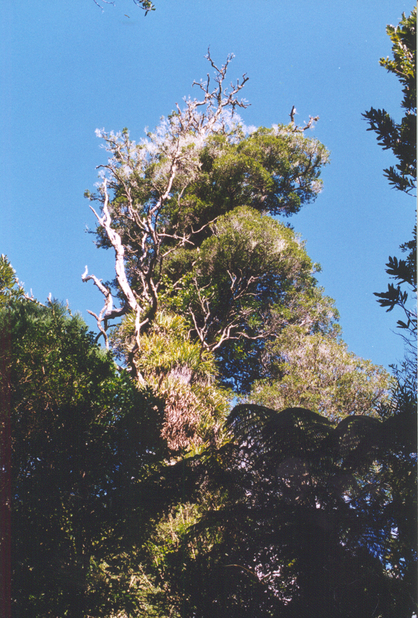 |  | 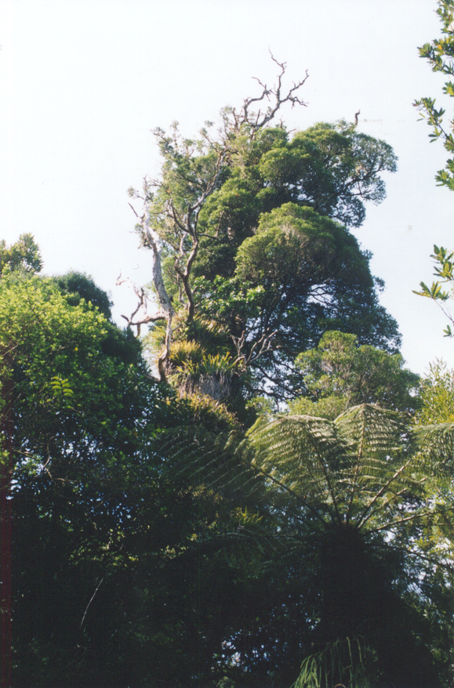
1996 |  | 1999

Robin also photographed the canopies of selected emergent rata in the Bull Stream block (Akatarawa saddle) and Kaitoke Regional Park areas to be treated for possum control next autumn. This will give us base information against which we can compare future improvements in canopy growth with the anticipated decline in possum numbers.

Access Policy

We had more discussions with Water Group managers about how vegetation management could add value to their requirements for high quality water from the current water collection areas. This ties in with the overall access policy, and how animal pests are controlled. We are close to agreement on goat control.

Forest Condition Assessment

We spent time perfecting a “Quickplot” method of forest assessment, and introduced Scott Farrell and Gareth Cooper to the concept. This technique enables rapid assessment of any particular parameter we believe is being affected.

3. Rural Fire Control (Geoff Cameron)

WRC Rural Fire District

After the Council approved the Landcare Committee recommendation to disestablish the Rural Fire District, the appropriate documents have been prepared. The Council chairman will offer to discuss the issue with the affected Mayors before the advertisement is placed. We will also meet with Upper Hutt City Councillors.

Fire Permits

Robin Blake issued 21 fire permits during the period. Some were for Guy Fawkes bonfires, which were not needed in the end.

The Craigs Flat situation has quietened right down, and no permit requests have come from there.

Millennium Preparations

This was again the main agenda item at the Rural Fire Co-ordinating Committee meeting. It is the subject of a separate paper to the Committee.

Catchment Fire Protection

Scott Farrell is taking the initiative with fire protection measures for the Wainuiomata catchment. He has introduced the Wainuiomata Bush Fire Force to the area, particularly the Moores Valley Track. He and Robin are talking with neighbours about creating a new fire pond as a water source with unused liners from the Upper Hutt Depot.

4. Management Activities (Geoff Cameron)

Environmental Asset Plan

I worked to get the Environmental Asset Plan reviewed by Audit New Zealand, and it is the subject of a separate Committee paper.

Riparian Management

I am a member of the riparian management group, brought together under the auspices of Regional Policy Statement implementation. We met during the period to discuss projects to be considered as part of LTFS.

Rimutaka Incline Recreation Area Harvesting

I joined a group of Landcare staff and Clive Anstey, the landscape consultant who prepared the original harvest impact plan. The objective was to review last year’s logging performance against that plan, and to begin preparation of a plan for the new area.

New Uniform

Robin Blake has been issued with the new Rangers uniform, in keeping with the co-ordinated Landcare approach. This is the third style of uniform Robin has had in his long service with Council.

Photographer of the Year

To complete the perception that Robin Blake is in danger of getting OOS in his shutter finger, he was retained to photograph various activities outside the forests for the Environment Division’s State of the Environment report. His skill as a photographer is recognised in photographic circles, but this is the first time he has worked for other departments in this activity.

GEOFF CAMERON
Manager, Natural Forestry

