Water Quality and Stream Health of the Waikanae River
A summary of SoE monitoring data

Summer Warr
Resource Investigations Section
Wairarapa Division

February 2002

Executive Summary

This report is a summary of Rivers State of the Environment (RSoE) monitoring data from Waikanae River as requested by WRC’s flood protection group. The report was requested as part of an exercise to assess impacts of flood protection works on the Waikanae River and how these may need to be monitored in the future.

Dominant forms of land use in the Waikanae catchment are indigenous forest near the top of the catchment, pastoral farming in the middle and lower reaches and urban development near the bottom of the catchment. The Waikanae River receives treated sewage from the Paraparaumu Wastewater Treatment Plant via the Mazengarb drain. Regular flood protection works are carried out over a stretch of the river up to approximately 7 km from the mouth. There are two RSoE sites on the Waikanae River, one at Reikorangi the other at the Oxbow boat ramp.

Physical, chemical and biological indicators monitored at the RSoE sites all showed a significant decline in water quality between the Reikorangi and Oxbow sites.

Significant seasonal variation was observed in most water quality parameters at the Reikorangi site and flow adjustment suggested that this was primarily influenced by catchment runoff. Water quality parameters at the Oxbow site showed either no seasonality or appeared to be influenced by seasonal factors other than catchment runoff.

A significant decrease in both plant available phosphorus levels and faecal coliforms has occurred at the Oxbow site since 1990. These declines coincide with an upgrade of the Paraparaumu WTP during 1993/1994 and are likely to be related to a improvement in effluent quality from this plant.

The decline in water quality down the length of the Waikanae River is likely to be a result of:

- Mazengarb Drain discharge
- Other rural and urban runoff
- Natural changes related to the estuarine nature of the Oxbow site

It is beyond the scope of the RSoE monitoring to specifically decipher impacts from flood protection works carried out on the Waikanae River. However, though there was no discernible relationship between trends in the RSoE data and flood protection works it is likely that these activities make some contribution to the decline in water quality down the length of the Waikanae River.
Contents

1. Introduction 1

1.1 Background 1
1.2 Description of Catchment 1
1.3 Catchment land use 2

2. Methods 3

3. Results 4

3.1 Temperature 4
3.2 Dissolved Oxygen 5
3.3 Turbidity 7
3.4 Faecal Coliforms 8
3.5 Nutrients 9
3.6 Ammonia 11
3.7 Macroinvertebrates 12

4. Discussion 14

4.1 Mazengarb Drain 14
4.2 Rural Runoff 14
4.3 Urban Stormwater and runoff 15
4.4 Flood protection works 15
4.5 Natural Causes 15

5. Conclusions 15

6. References 16

Introduction

1.1 Background

A summary of Rivers State of the Environment (RSoE) monitoring data from Waikanae River was requested by Wellington Regional Council’s flood protection group. This report was requested as part of an information gathering exercise to assess impacts of ongoing flood protection works on the Waikanae River and to identify future requirements for monitoring of the impacts of these activities.

As part of the Wellington Regional Council’s RSoE monitoring programme physical, chemical and biological indicators of water quality are monitored on the Waikanae River. Monitoring is carried out at two sites on the river, these are:

- Waikanae River at Reikorangi Bridge
- Waikanae River at Oxbow boat ramp (Fig. 1)

At each of these sites physical, chemical and bacteriological parameters are measured monthly while macroinvertebrates are monitored on an annual basis.

The objectives of this report is to analyse the RSoE data to:
- Assess the current state of water quality and aquatic ecosystems in the Waikanae River
- Identify any spatial, seasonal and temporal trends in water quality in the Waikanae River
- Suggest possible causes of changes in water quality and ecosystem health in the Waikanae River including identification of any links between trends in the RSoE data and flood protection works.

  - Description of Catchment

The Waikanae River is a gravel bed river which drains the south western portion of the Tararua Ranges and has a total catchment area of 149 km² (Fig. 1). The Waikanae’s main tributaries are:

- Maungakotukutuku Stream
- Reikorangi Stream
- Rangiora River
- Ngatiawa River

All main tributaries join the main channel above the Maungakotukutuku confluence. The river then flows through a passage in the coastal foothills and across the coastal plain. The monitoring site at the Oxbow boat ramp is subject to tidal influence and is often inundated by salt water.

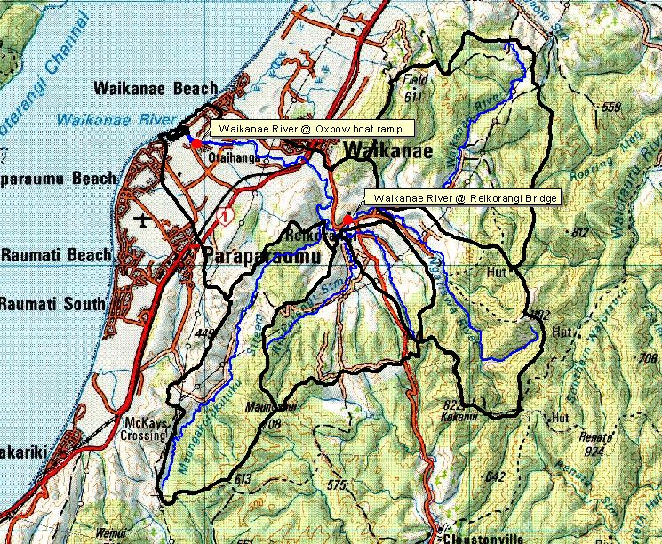
Figure 1. Map of the Waikanae River catchment (as delineated by black line), its main tributaries (blue line) and the location of the two SOE monitoring sites (red dots).

1.3 Catchment Land use
Indigenous forest covers approximately 36% of the Waikanae River catchment (NZLCDB 2001) much of which lies along the western boundary of the catchment in the Tararua Ranges. Approximately 7.7% of the catchment is planted in exotic forest. The other dominant land use within the catchment is pastoral farming which makes up approximately 34% of the total catchment area. Sheep and beef farming is the predominant form of pastoral farming in the catchment (Agribase 2001). Some deer farming occurs along the Ngatiawa River while the catchments only dairy farm is located near the bottom of the catchment.

Towards the bottom of its catchment the Waikanae River receives runoff from areas of both Waikanae and Paraparaumu townships. Treated sewage from the Paraparaumu WTP enters the Waikanae River near its mouth via the Mazengarb drain. In total, urban land use makes up approximately 2% of the catchment.

Wellington Regional Council carries out regular flood protection works over a stretch of the Waikanae River up to approximately 7 km from the mouth. These works involve regular rip rap and bank maintenance, gravel extraction and cross blading. Major river works, such as the diversion of part of the river to a new channel in 1997, are carried out intermittently.

2.0 Methods
Water quality monitoring has been carried out at each of the Waikanae River sites since 1990. Water Quality data from the two monitoring sites were flow adjusted using WQ Stat to remove flow effects prior to statistical analysis. Flow adjustment was carried out using flow data from the Wellington Regional Council hydrology site located on the Waikanae River at SHI.

For the purposes of this report physical and chemical data from the 2000-2001 period have been used to assess the current state of water quality and aquatic ecosystems in the Waikanae River. Spatial changes in water quality between the Reikorangi and Oxbow sites were assessed using the Kruskal-Wallis non parametric ANOVA using a p value of 0.05.

Seasonal trends in water quality were assessed from the entire data set from both flow adjusted and non-flow adjusted data using the nonparametric Kruskall-Wallis test at the p = 0.05 significance level. The seasonal boxplots presented are from non-flow adjusted data.

In order to assess long term trends in Waikanae River water quality the entire flow adjusted data set for each site was analysed. Parameters which did not exhibit seasonality were analysed using Sen’s slope tests while those that did were analysed using seasonal Kendall trend analyses. A significance level of p = 0.05 was used in all tests. Statistical analyses was carried out using WQ Stat and SYSTAT.

Due to data storage problems macroinvertebrate data from only 2000 and 2001 were available at the time this report was compiled.
3.0 Results

3.1 Temperature
Median temperature at the Reikorangi site was 11.9 ºC while that at the boat ramp was 13.9 ºC (Fig. 4(a)). Temperature at the Reikorangi site ranged between 5 and 16 ºC while that at Oxbow boat ramp ranged between 8 and 20 ºC. However, these results are based on single monthly measurements usually taken between 0900 and 1100 hours and do not take into account diel fluctuations in temperature.

Temperatures in the Waikanae River may fluctuate considerably over the course of a day, particularly during summer, when flows are lower and in areas where riparian vegetation is scarce. Sensitive macroinvertebrate species such as mayflies and stoneflies are thought to be adversely effected by temperatures of 20ºC and over (Quinn & Hickey 1990). Spawning of trout and native fish species is thought to be adversely affected by temperatures exceeding 25ºC (RMA, ANZECC 1992).

As could be expected temperature showed significant seasonal variation with highest temperatures at both sites experienced during summer and lowest temperatures during winter (Fig. 2).

Figure 2. Seasonal boxplots of temperature for (a) Oxbow and (b) Reikorangi sites.
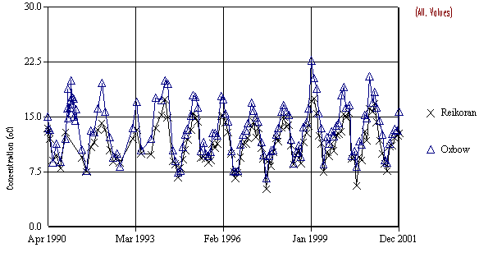
Figure 3. Time series graph of SOE temperature data at the Reikorangi Bridge and Oxbow boat ramp sites.

Temperature has shown a significant increase of on average 0.1 ºC /year at the Reikorangi Site since 1990 (Fig. 3). This trend may be related to a reduction in riparian vegetation cover at the site or to changes in the time of day at which measurements were made. No trends were discernible in temperatures at the Oxbow boat ramp site.

Figure 4. Boxplots of (a) temperature (b) dissolved oxygen (c) pH (d) conductivity (e) turbidity (f) dissolved reactive phosphorus (g) Ammonia (h) Nitrates and (i) faecal coliform SOE monitoring data at the Reikorangi and Oxbow sites from the period 2000-2001.

3.2 Dissolved Oxygen
There was a significant decrease in dissolved oxygen levels between the upper and lower sites on the Waikanae River with a median dissolved oxygen saturation of 103.1 % at Reikorangi and 88.2% at Oxbow (Fig. 4 (b)). As with temperature, dissolved oxygen levels can fluctuate considerably throughout the day. This daily fluctuation is not represented in the single monthly measurements comprising the Waikanae River SOE data.

Aquatic ecosystem guidelines state 80% saturation as the threshold level below which aquatic biodiversity is likely to be adversely effected (ANZECC 1992). Dissolved oxygen levels varied little at the Reikorangi site and were always above the 80% threshold. However, at the Oxbow site dissolved oxygen levels dropped below the 80% threshold on 8 occasions over the 2000-2001 period with the lowest % saturation of 35.7% measured during February 2000. The majority of these low DO levels occurred during summer periods.

There were no significant seasonal patterns in dissolved oxygen levels in the flow adjusted or non-flow adjusted data at the Reikorangi site (Fig. 5). Non flow adjusted data from the Oxbow site showed significant seasonal variation with lowest dissolved oxygen levels consistently occurring during summer months (Fig. 5). However, once flow was accounted for these seasonal patterns were not apparent. This suggests that the occurrence of low dissolved oxygen levels during summer at the Oxbow site is primarily related to low flows during this time.

Figure 5. Seasonal boxplots of dissolved oxygen for (a) Oxbow and (b) Reikorangi.
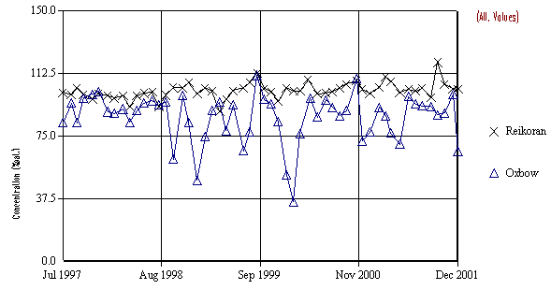
Since 1997 there has been a significant increase in DO levels of on average 1.26%/year at the Reikorangi site (Fig. 6). Reasons for this increase are unclear but may be related to increased algal growth at this site. DO levels as the Oxbow site showed no significant long-term trends.
Figure 6. Time series graph of SOE dissolved oxygen (%sat.) data at the Reikorangi Bridge and Oxbow boat ramp sites.

3.3 Turbidity
Turbidity levels increased significantly down the Waikanae River with a median turbidity of 2.3 NTU recorded at Reikorangi and 4.9 NTU recorded at Oxbow boat ramp (Fig. 4(e)). There was also a greater range of variation in turbidity levels at the Oxbow site than at Reikorangi. Turbidity ranged from 2 to 7.3 NTU at the Reikorangi site and from 1.1 to 14.99 NTU at the Oxbow site.

Non flow adjusted turbidity data from the Reikorangi site showed significant seasonal trends with highest median turbidity occurring during winter and spring (Fig.7). This seasonality was not apparent in the flow adjusted data suggesting that seasonal flow patterns are the main driver of turbidity fluctuations at this site.

There were no significant seasonal patterns in either the flow adjusted or non flow adjusted data from the Oxbow site (Fig.7). This suggests that factors unrelated to flow are responsible for fluctuations in turbidity at this site. Tidal activity and associated resuspension of sediment is likely to be an important factor effecting turbidity fluctuations at the Oxbow boat ramp site.

Figure 7. Seasonal boxplots of turbidity at (a) Oxbow and (b) Reikorangi sites (note log scale on Y axes).

There have been no significant changes in turbidity levels at either of the SOE sites since 1990 (Fig. 8).
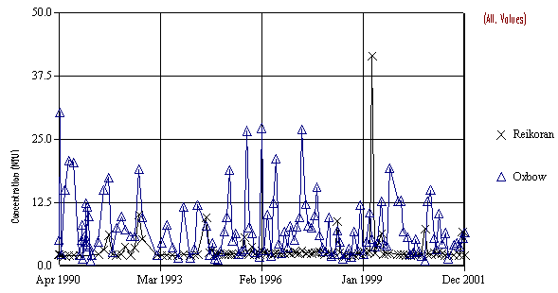
Figure 8. Time series graph of SOE turbidity (NTU) data at the Reikorangi Bridge and Oxbow boat ramp sites.

3.4 Faecal Coliforms
With a median of 265 cfu/100ml faecal coliform levels were significantly higher at the Oxbow boat ramp than at Reikorangi Bridge which had a median of 125 cfu/100ml (Fig. 4 (i)).

Current recreational guidelines use Escherichia coli as the preferred indicator of faecal contamination. E. coli levels have not been measured at either of the baseline sites. However, as E. coli is a member of the faecal coliform group there is usually a high correlation between the presence of faecal coliforms and E. coli (MFE 1999). With this in mind faecal coliform numbers are compared here to E. coli thresholds from current recreational guidelines.

The threshold level for safe recreational use is a running median of 126 E. coli/100ml (MFE, 1999). Faecal coliform levels where below the threshold level for recreational use at the Reikorangi Bridge site. At the Oxbow site faecal coliform numbers reached up to 2817 cfu/100ml and with a median of 265 cfu/100ml exceeded the threshold level for recreational use.

The Reikorangi site exhibited significant seasonal patterns in faecal coliform numbers with highest median levels occurring during the months of summer and autumn (Fig. 9). This seasonal pattern was still significant once flow variation had been accounted for indicating that seasonal variation in factors other than flow are primarily responsible for variation in faecal coliform numbers. Increased livestock access to streams during summer and autumn months may explain elevated faecal coliform levels during this time.

There were no significant seasonal trends in either the flow adjusted or non flow adjusted faecal coliform data at the Oxbow site. This suggests that loading of faecal coliforms at this site arises from constant, non-catchment runoff related sources.

Figure 9. Seasonal boxplots of faecal coliform numbers at (a) Oxbow and (b) Reikorangi sites (note log scale of Y axes).

There has been no significant change in faecal coliform numbers at the Reikorangi bridge site since 1990. At the Oxbow boat ramp site there has been a significant decrease, of 61 cfu/100ml/year, in faecal coliform numbers since 1990 (Fig. 10). This decline occurred primarily between 1993 and 1994 and coincides with an upgrade of the Paraparaumu wastewater treatment plant.

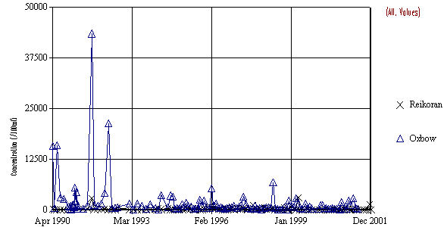
Figure 10. Time series graph of SOE faecal coliform (cfu/100ml) data at the Reikorangi Bridge and Oxbow boat ramp sites.

3.5 Nutrients
Both plant available phosphorus and nitrogen levels were significantly greater at the Oxbow boat ramp site than at Reikorangi (Fig.s 4(f)&(h)). At Reikorangi Dissolved Reactive Phosphorus (DRP) concentrations were below the detection limit of 0.010 g/m³ on every occasion, while at the Oxbow site median DRP concentration was 0.018 g/m³. The median nitrate concentration at Reikorangi was 0.169 g/m³ while that at Oxbow was 0.322 g/m³.

Periphyton growth was minimal at both sites throughout the 2000-2001 period. Minimal periphyton growth at the Reikorangi site is likely to result from a combination of low nutrient levels, greater flow velocities and shading from riparian vegetation. Lack of periphyton growth at the Oxbow site is likely to be primarily a result of lack of a suitable substrate as this site has a muddy/sandy bottom (Jane Taylor pers. comm.).

As DRP concentrations were below detection limits on almost all occasions at the Reikorangi site it was not possible to assess seasonal patterns in this parameter.

At the Oxbow site there were no significant seasonal trends in DRP concentration in the non-flow adjusted data. However, once flow was taken into account a significant seasonal trend became apparent with highest DRP concentrations occurring during summer and autumn months (Fig.11). This pattern may be related to estuarine nutrient transformation cycles, with increased activity occurring during summer and autumn in response to daylight and temperatures.

A significant seasonal pattern was detected in nitrate concentration in both flow adjusted and non-flow adjusted data from the Reikorangi site. At this site nitrate concentrations were highest during spring and winter and lowest during summer indicating that they are primarily driven by the amount of runoff received from the surrounding catchment (Fig. 12).

Figure 11. Seasonal boxplots of dissolve reactive phosphorus (DRP) for (a) Oxbow and (b) Reikorangi sites (note log scale of Y axes).

Nitrate concentrations at the Oxbow site showed no significant seasonal trends and medians were similar throughout the year (Fig. 12). This suggests that sources of nitrates to the lower Waikanae River come from a constant source, which is not effected by variation in catchment runoff. The influence of the estaurine environment in nutrient flux’s is the most likely driver.

Figure 12. Seasonal boxplots of nitrate concentrations at (a) Oxbow and (b) Reikorangi sites (note log scale of Y axes).

There has been no change in nutrient levels at the Reikorangi site since 1990. However, at the Oxbow site DRP and nitrate levels have shown significant decreases of 0.00548 g/m³/year (Fig. 7) and 0.025 g/m³/year respectively (Fig.s 13 &14). As with faecal coliform numbers these declines occurred principally during the 1993-1994 period and coincided with upgrading of the Paraparaumu waste water treatment plant.

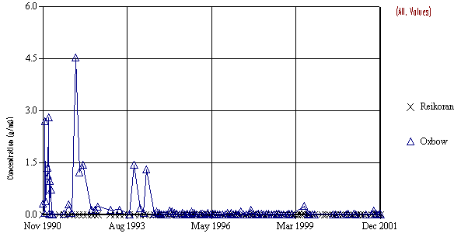
Figure 13. Time series graph of SOE Dissolved Reactive Phosphorus (g/m³) data at the Reikorangi Bridge and Oxbow boat ramp sites.

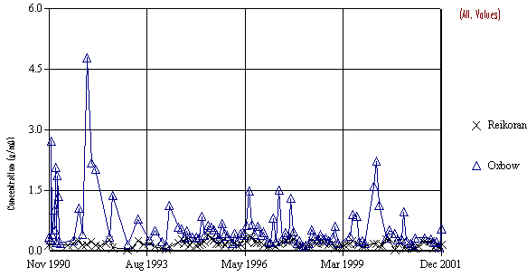
Figure 14. Time series graph of SOE nitrate (g/m³) data at the Reikorangi Bridge and Oxbow boat ramp sites.

3.6 Ammonia
Ammonia levels at the Reikorangi site were below detection limits on all occasions. Ammonia concentrations at the Oxbow site were significantly higher than that at Reikorangi with a median of 0.092 recorded (Fig. 4(g)).

Ammonia data from the Reikorangi site could not be assessed for seasonal patterns as all were below the detection limit. Once flow had been accounted for ammonia concentrations at the Oxbow site showed significant seasonal variation with median ammonia levels greatest during summer months and lowest during winter and spring (Fig. 15). This indicates that seasonal factors other than catchment runoff are responsible for variation in ammonia levels at this site. This again is likely attributable to estuarine dynamics.

Figure 15. Seasonal boxplots of ammonia at (a) Oxbow and (b) Reikorangi sites.

There has been no significant change in ammonia levels at either of the SOE sites on the Waikanae River since 1990 (Fig. 16).

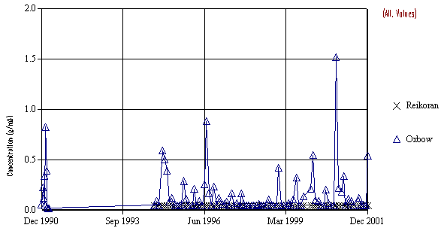
Figure 16. Time series graph of SOE ammonia (g/m³) data at the Reikorangi Bridge and Oxbow boat ramp sites.

  - Macroinvertebrates

Assessment of changes in stream health between the Reikorangi and Oxbow sites using macroinvertebrate indicators is complicated by significant saline influence at the Oxbow site. Tidal and saline influenced macroinvertebrate communities are considerably different to those in purely freshwater environments and are naturally associated with taxa such as amphipods which are considered to be pollution tolerant in freshwater environments. This makes it difficult to discern the effects of catchment activities from natural estuarine influences between the two sites.

There are a number of differences in the macroinvertebrate communities between the Reikorangi and Oxbow sites. Macroinvertebrate community data from the past two years shows that the Waikanae River at Reikorangi supports a diverse range of Ephemeropteran (mayfly), Plecopteran (stonefly) and Trichopteran (caddisfly) taxa. These taxa are particularly pollution sensitive and the percentage of Ephemeroptera, Plecoptera and Trichoptera (EPT) taxa is commonly used as an indicator of ecological health. Percentage EPT taxa at Reikorangi was on average 60% over the last two years while that at Oxbow was 30% (Table 1).

As well as having considerably lower percentages of EPT taxa, macroinvertebrate communities at the Oxbow site were dominated by orthoclad midges, amphipods, gastropods and paratyiid shrimps, all of which are considered to be tolerant of organic pollution. These pollution tolerant taxa were absent or of low abundance at the Reikorangi site.

Table 1. MCI, SQMCI, % EPT taxa and number of taxa results from 2000 and 2001 from (a) Reikorangi and (b) Oxbow sites on the Waikanae River
(a)
Year | MCI | SQMCI | % EPT taxa | No. of taxa
2000 | 141 | 7 | 54 | 8
2001 | 135 | 8 | 65 | 12

(b)
Year | MCI | SQMCI | % EPT taxa | No. of taxa
2000 | 110 | 5 | 39 | 10
2001 | 97 | 4 | 20 | 6

Macroinvertebrate Community Index (MCI) and Semi Quantitative Macroinvertebrate Community Index (SQMCI) values decreased considerably between the Reikorangi and Oxbow sites (Fig. 17). Macroinvertebrate communities present at Reikorangi Bridge indicate good water quality while those at Oxbow boat ramp indicate possible mild to moderate pollution.

Figure 17. SQMCI results from Reikorangi and Oxbow SOE monitoring sites for the years 2000 and 2001.

4.0 Discussion

Analysis of physical, chemical, bacteriological and macroinvertebrate SOE data suggest that at Reikorangi Bridge the Waikanae River has good water quality while near its mouth the Waikanae River is mildly to moderately polluted.

Analysis of seasonal variation at both sites shows that variation in water quality at the Reikorangi site is largely related to seasonal variation in catchment runoff and flow. While at the Oxbow site this often shows no seasonal patterns or is effected by seasonal factors other than flow such as the estuarine influence.

These spatial and temporal changes in water quality and ecological health in the Waikanae River are likely to be attributable to a number of different causes including discharge from the Mazengarb drain, rural runoff, urban stormwater runoff, river bed works and natural estuarine influences.

4.1 Mazengarb Drain
The Oxbow boat ramp site is directly adjacent to the confluence of the Mazengarb drain. The Mazengarb drain has extremely poor water quality and frequently fails to meet aquatic ecosystem guidelines for dissolved oxygen, turbidity, BOD and ammonia. The Mazengarb also has high concentrations of plant available nutrients such as nitrate and DRP and faecal coliform numbers consistently exceed recreational guidelines (Warr 2001; Stansfield 2000).

Discharge from the Mazengarb drain is likely to be a major contributor to the decline in water quality near the mouth of the Waikanae River. The Mazengarb was identified as being a major contributor to elevated faecal coliform and turbidity levels in the lower Waikanae River (Berry, 1998a).

The Mazengarb drain is a low-lying waterway, which receives runoff from both agricultural and urban land use including the Paraparaumu Wastewater Treatment Plant and the Paraparaumu landfill.

Significant declines in faecal coliform and nutrient levels at the Oxbow boat ramp site may be partially attributable to improvements in the quality of runoff from the Paraparaumu Wastewater Treatment Plant. The most marked decreases in these parameters coincide with the Paraparaumu sewage treatment plant upgrade carried out in 1994. Unfortunately baseline monitoring has only been carried out on the Mazengarb drain since 1997 so it is not possible to ascertain whether corresponding improvement in Mazengarb water quality occurred around this time.

4.2 Rural Runoff
Rural land use within the catchment is likely to contribute to the decline in water quality down the length of the Waikanae River through nutrient and sediment loading via runoff as well as through direct inputs and erosion from livestock. Sheep and beef farming is a comparatively low intensive land use but is still likely to make considerable nutrient and sediment contributions to the Waikanae River.

4.3 Urban Stormwater and Runoff
The lower reaches of the Waikanae River receive runoff from parts of both Waikanae and Paraparaumu townships. Urban stormwater can contain elevated levels of suspended sediments, faecal bacteria, nutrients as well as hydrocarbons and other toxic substances. Such contributions are likely to be contributing to the decline in water quality observed at the Oxbow boat ramp site. Berry (1998, 1999) identified stormwater runoff from the Otaihanga Domain area to be a major source of faecal contamination to the Waikanae River. This contamination was thought to originate primarily from animal wastes from the streets of the Otaihanga suburb.

4.4 Flood Protection Works
Though there was no discernible relationship between trends in the RSoE data and flood protection works it is likely that these activities make some contribution to decline in steam health down the length of the Waikanae River. Berry (1998) reported turbidity levels of up to 40 NTU downstream of cross blading work carried out by the Wellington Regional Council’s Rivers Department on the Waikanae River during November and December of 1997.

4.5 Natural Causes
The tidal influence and estuarine nature of the lower portion of the river is likely to have considerable influence over water quality at the Oxbow site. In particular, lack of seasonality in water quality parameters recorded at the Oxbow site is likely to be a result of estuarine influence. Also, high turbidity levels recorded near the mouth of the Waikanae River may be partially attributable to the estuarine nature of the site in which the silty substrate is resuspended during tidal activity.

5.0 Conclusions

Analysis of state of the environment data from the Waikanae River suggests good water quality in the upper catchment and mild to moderate pollution near the mouth.
Seasonal variation in water quality at Reikorangi is primarily influenced by catchment runoff while water quality at the Oxbow site shows either no seasonality or is influenced by seasonal factors other than catchment runoff.

The significant decline in water quality and ecological health between the two RSoE sites on the Waikanae River is likely to be primarily a result of:

- Mazengarb drain discharge
- Other rural and urban runoff
- Natural estuarine influences

Significant decline in faecal coliform and nutrient levels near the mouth of the river are likely to be a result of improvements in the quality of surface runoff from the Paraparaumu Sewage Treatment Plant to the Mazengarb drain.

There were no discernible relationships between trends in water quality and macroinvertebrates in the Waikanae River and flood protection works. However, these activities are likely to make some contribution to decline in steam health down the length of the Waikanae River.
6.0 References

ANZECC, 1992. Australian Water Quality Guidelines for fresh and marine waters.

ANZECC, 2000. Australian and New Zealand Guidelines for Freshwater and Marine Water Quality.

Berry, A. 1998. An Investigation into the Sources of Faecal Contamination and Turbidity in the Waikanae River. WRC/RINV-T-97/64

Berry, A. 1999. Waikanae River Water Quality Follow-up Investigation. WRC/RINV-T-99/2.

Ministry for the Environment. 1999. Recreational Water Quality Guidelines.

Quinn, J.M.; Hickey, C.W. 1990. Characterisation and classification of benthic invertebrate communities in 88 New Zealand rivers in relation to environmental factors. New Zealand Journal of Marine and Freshwater Research 24: 387-409.

Stansfield, B. 2000. Annual Freshwater Quality Report for the Wellinton Region 1999-2000. WRC/RINV-T-01/03.

Warr, S. 2001 Annual Freshwater Quality Report for the Wellington Region 2000-2001. WRC\RINV-G 01/34.

Wellington Regional Council, 1994. Hydrology of the Kapiti Coast. WRC/C-T/G-94/13.

